**West Moors Town Council**

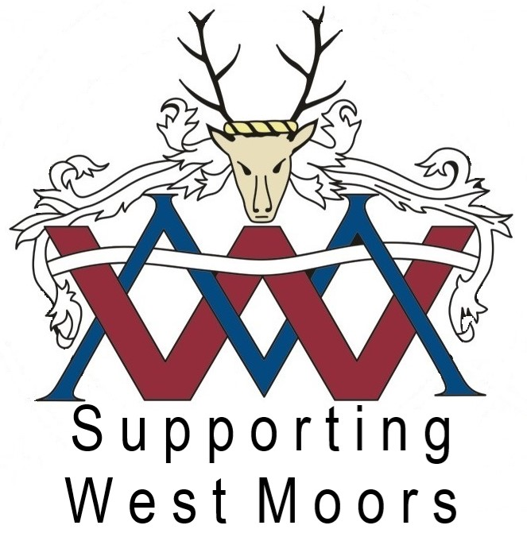

**PRESS RELEASE**

**Children’s Design a Christmas Card Competition 2023**

Children attending local First and Middle Schools and/or that are residents of West Moors, were given the opportunity to design a new Christmas card for West Moors Town Council to send out this year.

The children had to design a Christmas picture, of any style, that could be scanned onto the Christmas cards and judged by the Chair of the Council.

As in previous years, the decision making was very difficult and so many children deserved commendations and thanks.

It is always so rewarding receiving such cute, talented and creative pictures.

**All winners this year, were from West Moors Middle School:**

**The Winner, Nalani Silk, year 7 drew a cosy village Christmas scene.**

**For this she will receive a pack of 20 printed Christmas cards with her winning design on the front, as well as an arts and craft gift**

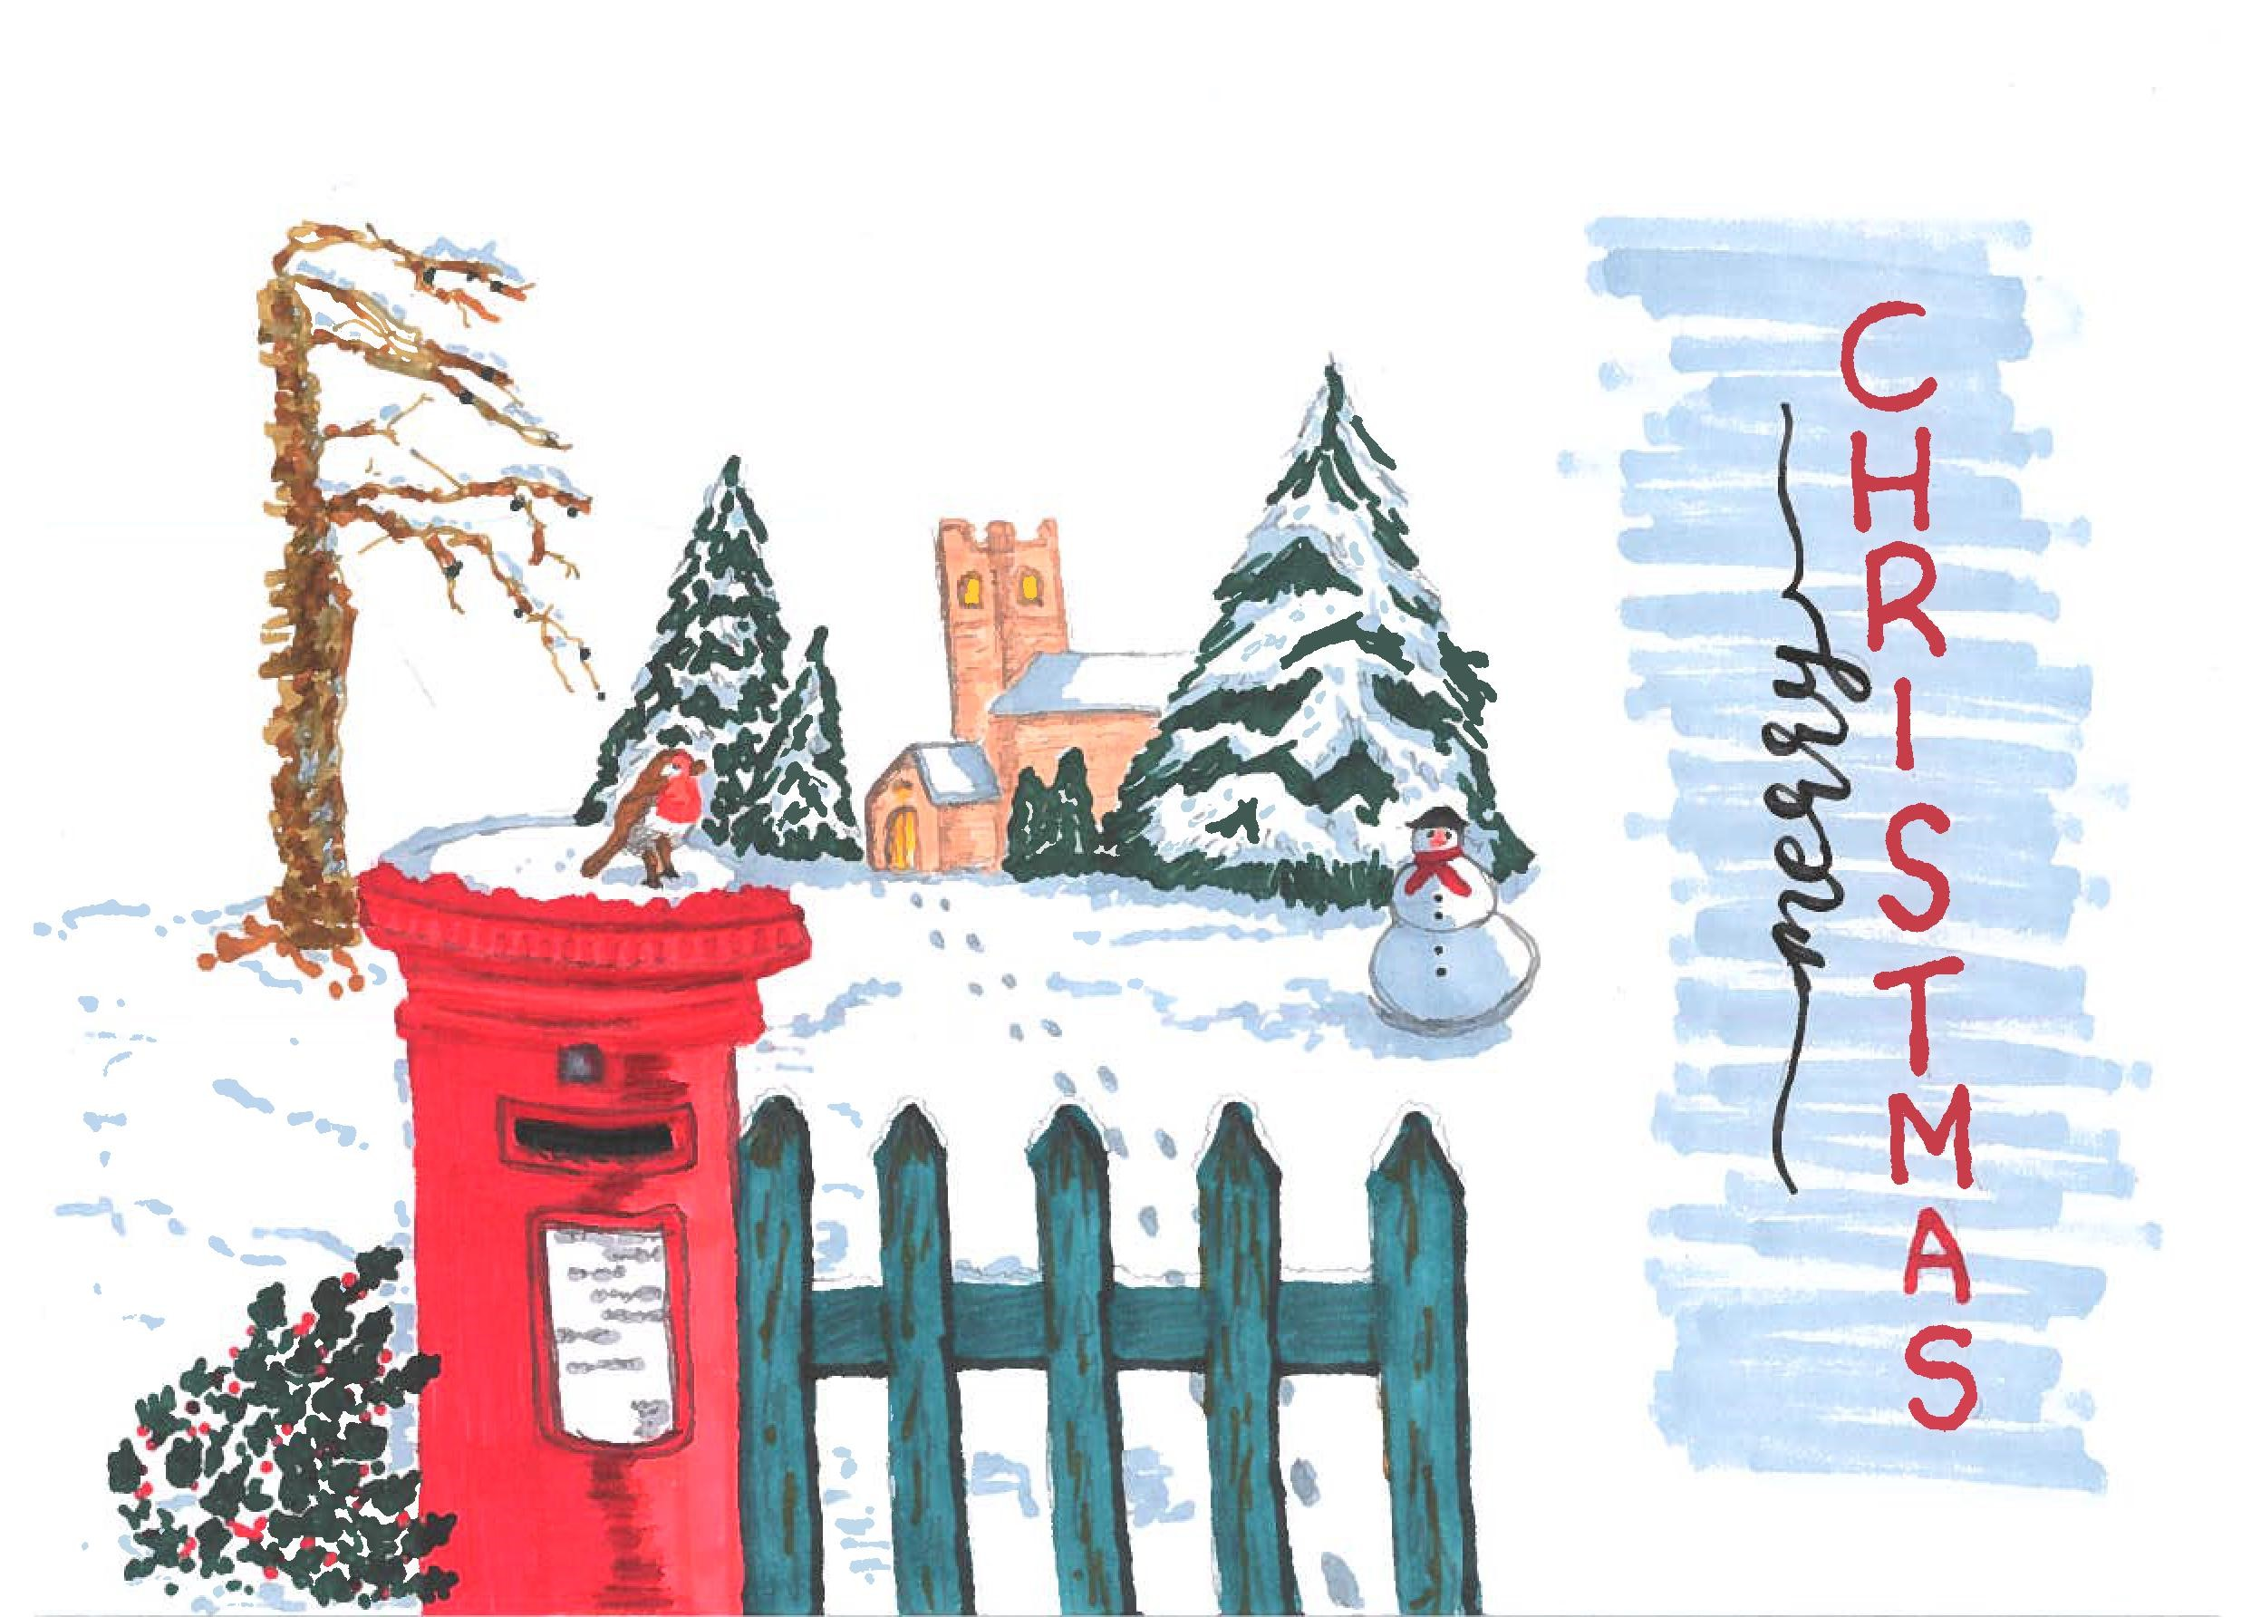

**.**

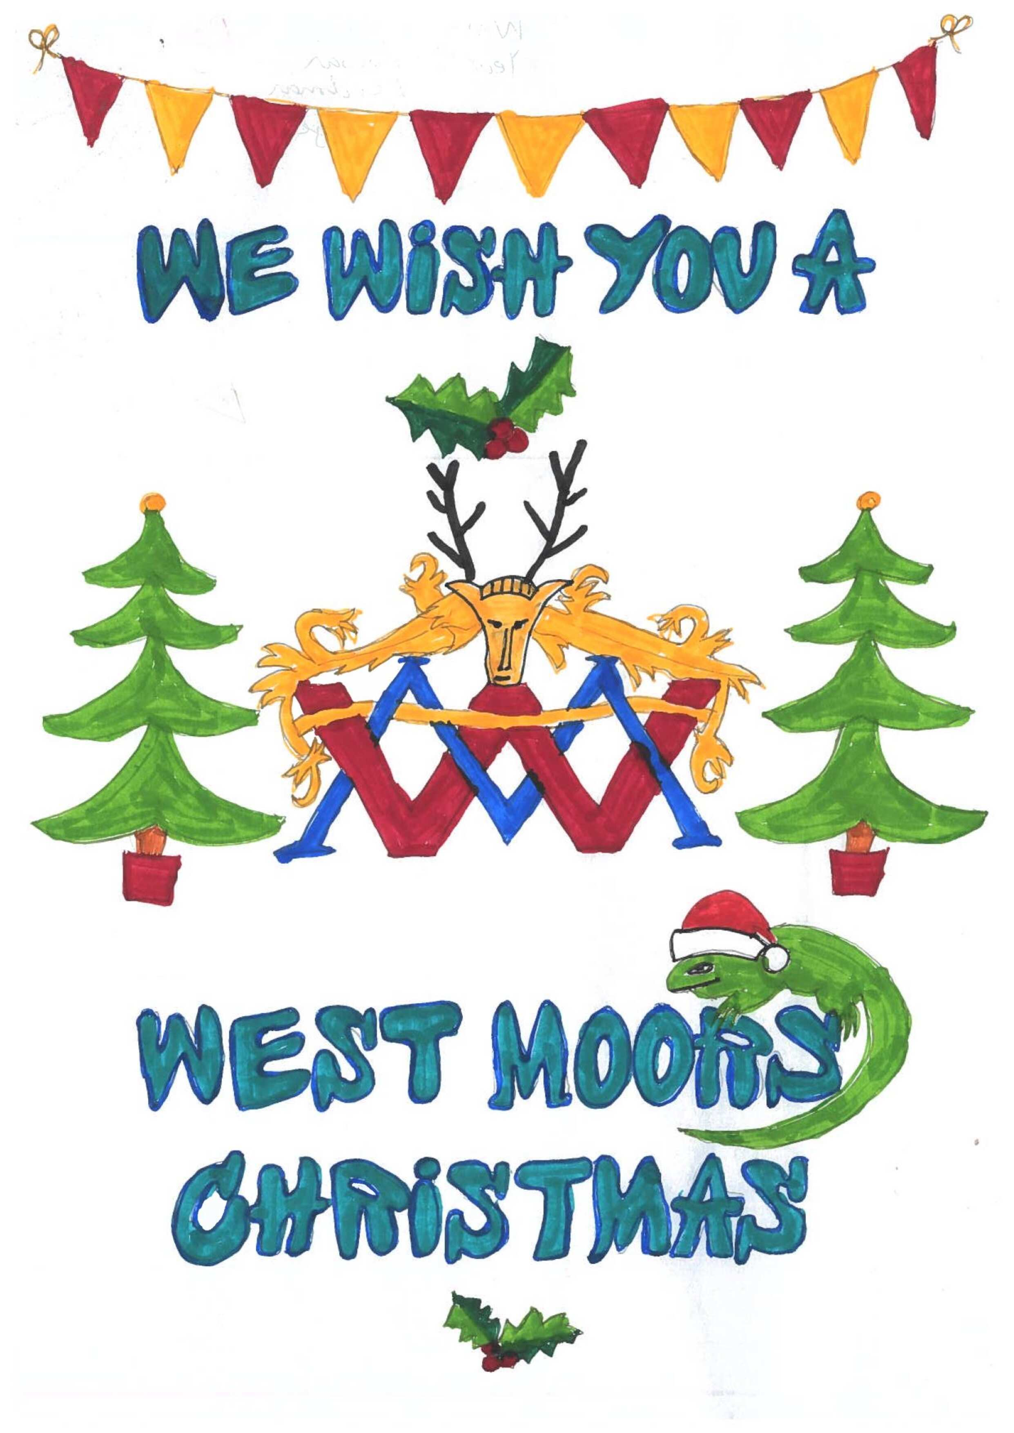

**Runner up 1, Rowan Reedman, Year 5, showed loyalty to his School and local Council, with both their logos in the design.**

**.**

**Runner up 2, Dalia Ardelean from year 7.**

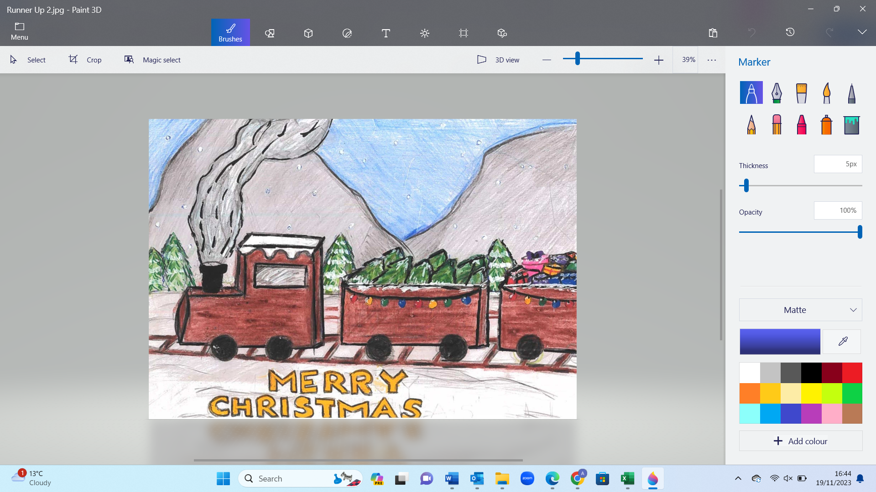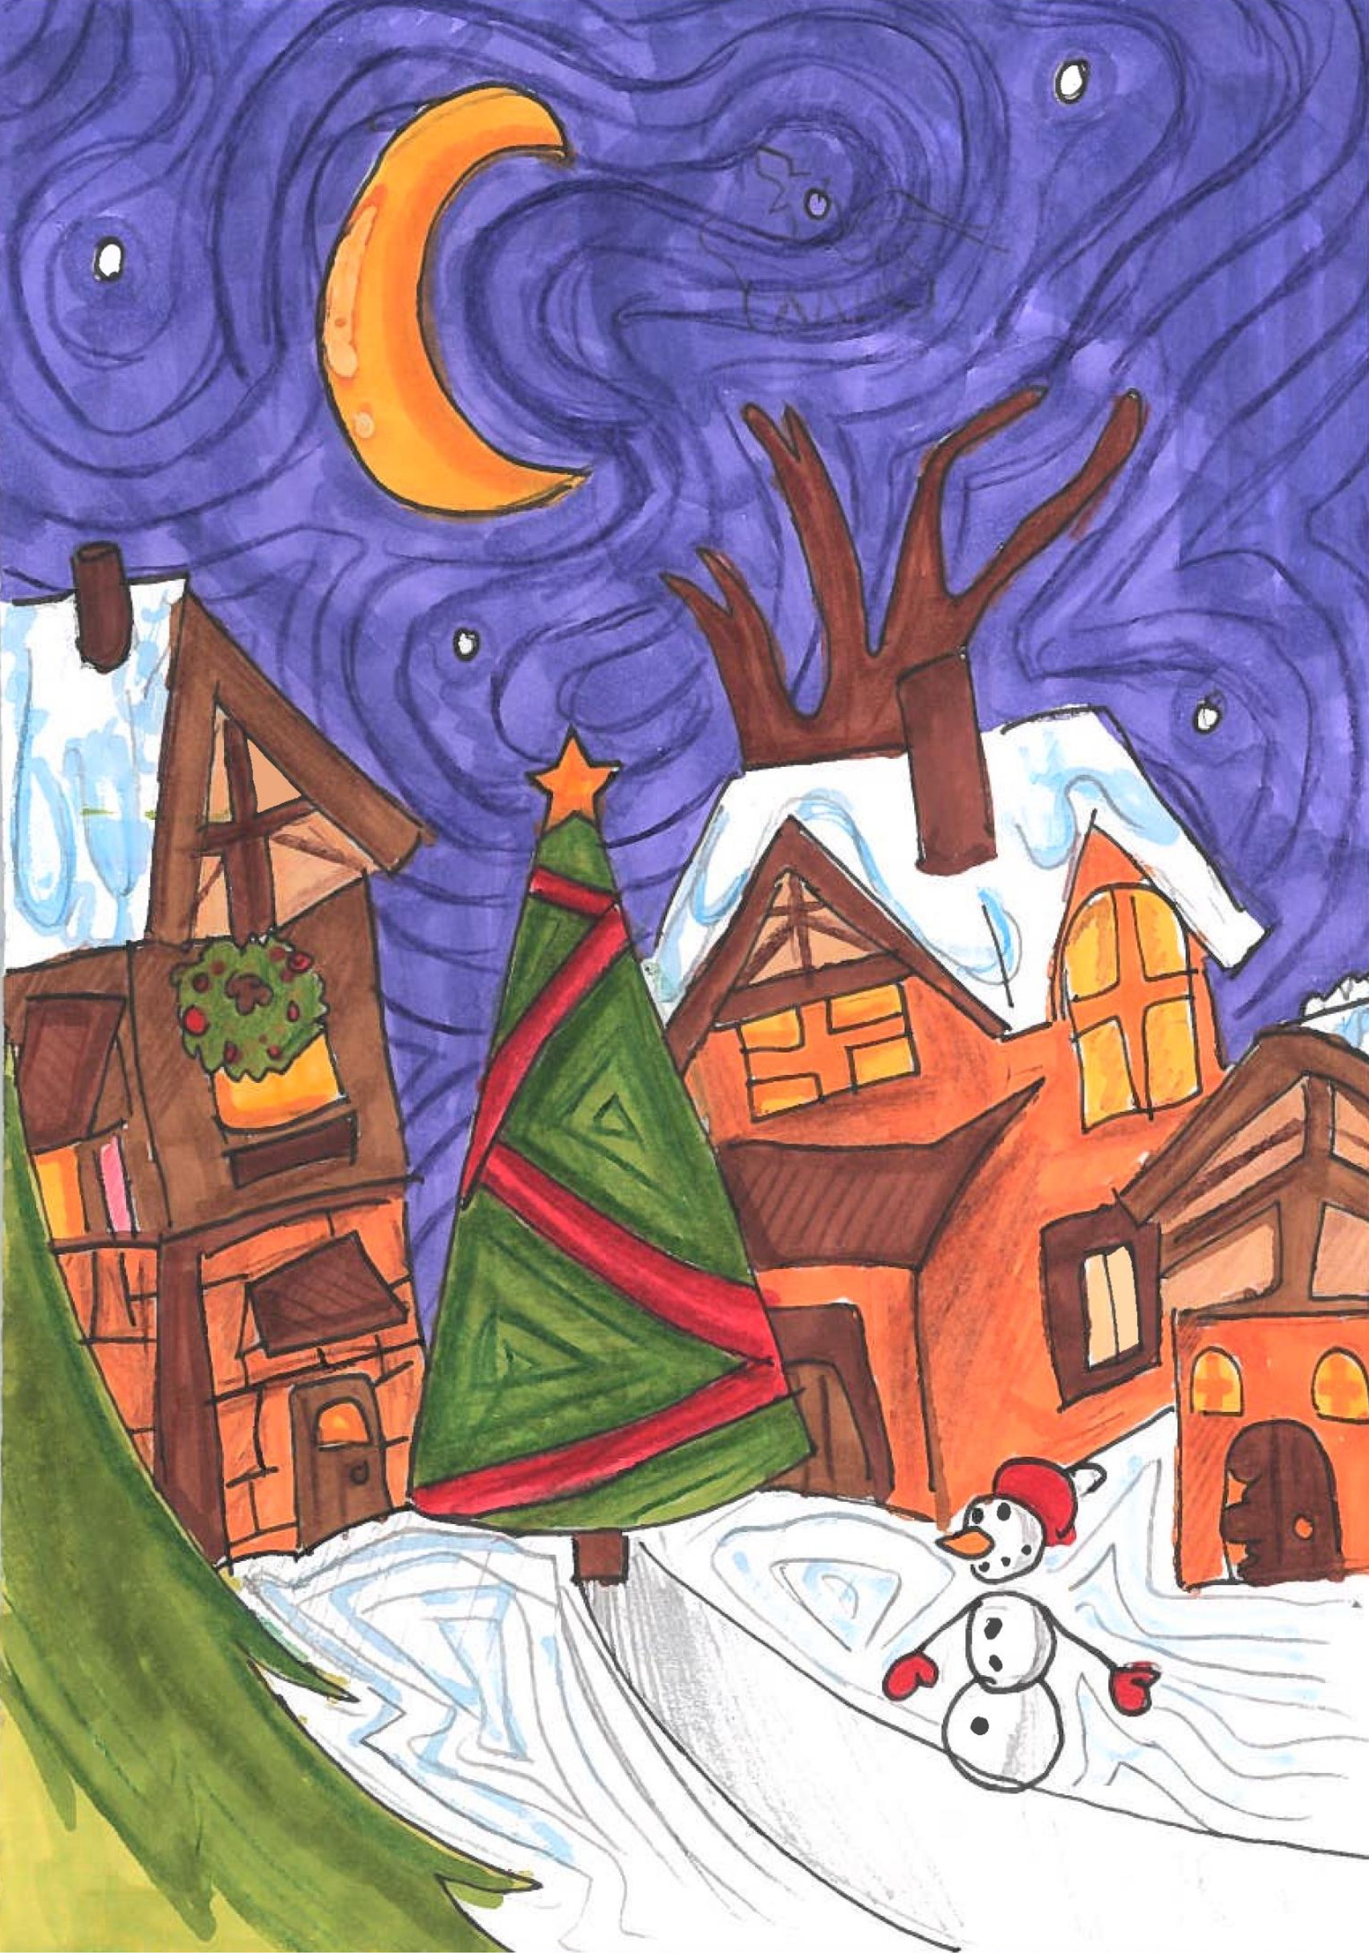

This year, due to the entries being of such good standard, the independent judge could not decide on just 2 runners up, so he has sponsored a 3rd Runner Up **Runner Up 3 Madison Trim (Right), from year 7.**

**The Runners Up will both receive an arts and craft gift too.**

**Thank you to everyone that took part.**