East Dorset
District Council

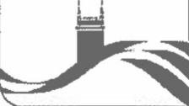
Contact: | Mrs Kay Mills
Telephone: | 01202 795219
E-mail: | kmills@christchurchandeastdorset.gov.uk
Our Reference: | DS/KEM
Your Reference
Date: | 31 May 2016

Chairman of Council
Council Offices
Furzehill
Wimborne
Dorset BH21 4HN
Ms Amie Fawcett
Assistant to the Clerk
West Moors Parish Council 4 Park Way
West Moors
BH22 OHL
Dear Amie
West Moors 60th Anniversary Celebrations
I am writing to say how much I enjoyed the various events throughout the week of celebrations in West Moors.
The West Moors events certainly made for a wonderful first week as Chairman of Council.
Kindest regards
Yours sincerely
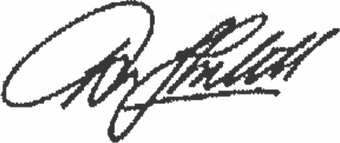

Chairman of Council

