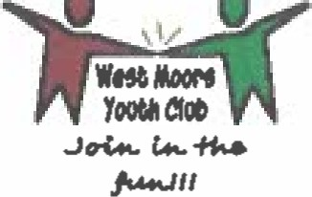
O
0
WEST MOORS YOUTH & COMMUNITY CLUB
Palethorpe House
Fryer Playing Field, Bond Avenue
West Moors Dorset BH22 OLL
(Reg. Charity No. 299191)
2 Teasel way
West Moors, BH22 OPQ
2nd January 2021
Am: Judi Weedon (Clerk to the Council) c/o West Moors Town Council, 4 Park way,
West Moors, Ferndown,
Dorset,
BH22
2nd January 2021
Re: West Moors Youth Club funding
Dear Judi,
On behalf of West Moors Youth & Community Club Committee and all its Youth Members I would like to wish you, Amie and West Moors Town Council a very safe and healthy start to 2021. I am sure we all agree that 2020 has been an exceedingly difficult time for the community and so appreciate all that the Town Council has done throughout the pandemic.
I also wish to pass on my appreciation to the Town Council for the very generous funding of El 5,692.06, which contributes towards Club roof repair (E3,954.86) and our annual revenue and staff salaries (Cl 1,737.20). Without funding the Club would not be able to continue in all it does to support our young youth of West Moors and the surrounding area.
I am pleased to confirm the new roof was completed during July 2020 which safeguards the building for many years to come. Thanks going to Trevor Umney (Roofsmiths), as well as our very own project management team Chris Yeo and Fiona Hallam.
I also wanted to let the Town Council know that the Committee has been preparing for the Return To The Club (RTTC). We have been following government guidelines in readiness which has resulted in the Club having had a professional deep clean, added Covid Safety signs, 2m spacings, purchased masks and hand sanitisers, use of single entrance and exit etc., etc., We had originally hoped that the RITC would start as schools go back during January but given the current growing pressure for English schools to stay shut this is now unlikely. But please be reassured that as soon as it is possible to implement RITC in a safe environment we have taken all steps to be ready.
Once again please accept my personal gratitude on behalf of the Committee for the continued support shown by West Moors Town Council.
Yours sincerely,
Kurt Hallam: Chairman West Moors Youth & Community Club

