BLACKFIELD FARM
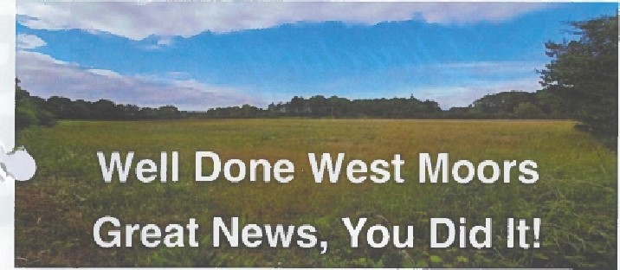
The Blackfield Farm planning application has been REFUSED and we'd like to a huge

THANK YOU
to everyone that has helped fight this battle to protect our beautiful countryside. We'd like to special thank you to West Moors Town Council for their support.
West Moors is a special place. Those of us that live here know it and our families know it. It may not be well known beyond its borders but it's quiet and unassuming nature is part of its charm.
Blackfield Farm's ecology is now recognised by Natural England to be of County Importance, a proven part Of a rare and special environment - thanks to you, tie people of West Moors.
We stood up against unnecessary development, joined by a sense of community, for the most noble of causes, to protect the land, the countryside and our community: so it can be left for our children and future generations.
It may not be over but today we can celebrate and be proud of our spirit, by West Moors Residents
To advertise in this magazine, call 01202 894397

