West Moors Dementia Action Group (DAG)
AGENDA

Meeting Tuesday 24th September 2024
2-3pm at The Hall at St Mary's WM

- Apologies, Introductions & Welcome: (5 mins)

- Actions from notes of last meeting: (5 mins)

- DAG publicity: updates & next actions (10 mins)

    - Revised Poster for GP surgery & elsewhere: agree draft/placing
    - West Moors Directory: August, Sept & future editions content
    - Living Well Magazine: Autumn edition & deadline
    - Facebook page: brief update
    - Banner order / purchase
    - DAG Website?

- Westival stall: review (5 mins)

- Revisit Aims & Objectives of DAG (30 mins): 3 papers attached.

    - Needs, Vision and DAG Actions in West Moors
    - Questionnaire to residents? identify desired outcomes
    - How do we engage more residents of West Moors into the DAG?
    - Dementia friends training: local schools & businesses?

- Fundraising (2 mins)

    - WMTC grant application
    - GoFundMe update

- Any other business (3 mins)

- Date of next meeting

Interesting snippets:

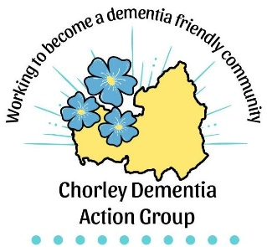 | Alzheimer’s Society:  “World Alzheimer's Month takes place every September and World Alzheimer's Day is on 21 September each year. It's a global opportunity to raise dementia awareness and support people affected by the disease.”  

